

**The Active team are very excited about their exhibition**

A new art exhibition is on by the children and young people from the Active group is on display until 12th June on level 2 on the ATC corridor. This exhibition offers a fantastic insight into some of the individual and group projects from the last couple of years. Come and learn about how young people’s views have been put into action with collaborations in and outside the trust, within our community, and with local and national organisations.

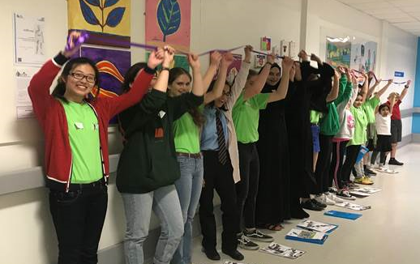

www.volunteering.cuh.org.uk

3rd May 2019

**Volunteer Awards Lunch**

Just a quick reminder that the Annual Volunteer Awards and Celebration lunch will be taking place on **Thursday 6 June 2019**.

We will be sending out invitations in due course.

**If you believe you are due an award this year, please let us know – awards are given for 5, 10, 15, 20, 25 etc years’ service**



The office is closed bank holiday Monday If you want to volunteer you may or just enjoy long weekend

**Volunteers Currently Going Through Compliance Checks**

To all our Volunteers who have been / are currently engaged in a recruitment compliance check with CUH Recruitment. Thank you for your patience with this, we know some of the emails have been confusing and frustrating. We are now drawing to a close on this. Our recruitment team having been working hard to try to resolve this and your kind cooperation and consideration in working together with them is very welcome. If you are feeling frustrated /concerned /anxious about this – please raise this directly with the Volunteer Services team so we can liaise on your behalf and help to resolve this. If your checks remain outstanding our Volunteer team will call you shortly to see how we can help you complete these.

Many thanks

**Active looking for volunteers**

Are you someone who would like to help the Active group make the hospital more child-friendly? Active are looking for regular support for this group of young volunteers. You will work alongside hospital staff to ensure the group safety and effectiveness and enjoy helping individuals aged 8-18 years old work on a variety of projects. No specific experience needed, but a passion to help and support children and young people volunteer. You will be fully supported by the Active Co-ordinator and not left in charge. To find out more please contact Kirsty.Lothian@addenbrookes.nhs.uk, Active Co-ordinator.

# Dates for your diary …..

Dementia Training 6th June 10:00-12:00

Supported Online Training 14th May 9:00-12:00

Face to Face Mandatory Training 15th May 9:30-11:30

Sight Guiding Training 15th May 12:30-13:30

**Volunteer Forum** 16th May 16:00-17:00

Contact Centre Shadowing 23rd May 13:00-16:00

Supported Online Training 30th May 13:00-16:00

Dementia Training 6th June 10:00-12:00

Supported Online Training 10th June 13:00-16:00

Grief and Loss Training 24th June 10:00-12:00

*Please let us know if you’d like to attend or more information by emailing* [***volunteer@addenbrookes.nhs.uk***](mailto:volunteer@addenbrookes.nhs.uk)