VOLUNTEER HANDBOOK
& Key Policy and Terms

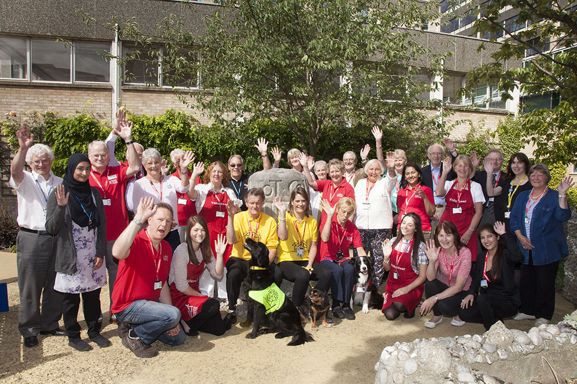

INDEX

- Welcome
- About our hospitals
  - Our hospitals
  - Volunteer roles
  - Trust values: Together – Safe, Kind, Excellent
  - Trust policies and procedures
    - Safeguarding children and vulnerable adults
    - Raising concerns about patient care and other matters
    - Equality and diversity
    - Confidentiality and data protection

- Security
  - ID Badge
  - Signing in and out
  - Fire safety
- General information
  - Travelling to and from the hospital site
  - Dress code
  - No smoking on site
  - Alcohol and substance misuse
  - Valuables and personal belongings
  - Acceptance of gifts
  - Insurance and liability
  - Claiming benefits
  - Social media and social networking
  - Change of circumstances/health status
  - Public Relations

- Health and safety
  - Your responsibilities
  - Moving and handling
  - Hand hygiene/infection control
  - Incidents

- Training and support
  - Induction and training
  - Support and supervision
  - Communications and feedback
  - Dealing with complaints

- Attendance
  - Reliability, illness and holidays
  - Change of volunteer placement
  - Taking a break from volunteering
  - Unsuitability for the volunteer role
  - Finishing your volunteering
- Expenses and discounts
  - Travel expenses
  - NHS Discounts
- Thank you

- Appendices
Welcome

Dear Volunteer

I extend a warm welcome to you in your volunteering role!

Volunteers at Cambridge University Hospital are a great asset and provide an invaluable service. You help us to make life easier for both our patients and their families, by supporting our staff in caring for patients, or by helping out behind the scenes. Each year, hundreds of volunteers give up their free time on a regular basis to help patients throughout the hospital. We aim to ensure that volunteers enjoy their role, feel fully supported and also gain much from their experience.

The purpose of this handbook is to provide you with a range of information and guidance about all aspects of volunteering, whatever your particular volunteer role. Please keep this booklet as a handy reference.

If you need to know something that is not within the handbook, please get in touch with your placement supervisor in the area that you volunteer in, or the Voluntary Services department.

Thank you for choosing to volunteer with us and I hope that you find volunteering with Cambridge University Hospitals NHS Foundation Trust rewarding and enjoyable.

Yours sincerely

David Wherrett

Director of Workforce

About our hospitals

Cambridge University Hospitals is one of the largest and best-known hospital Trusts in the country. As the local hospital for our community we deliver care through Addenbrooke’s and the Rosie hospitals.

We are also a leading national centre for specialist treatment, a government-designated comprehensive biomedical research centre, one of only five academic health science centers in the UK and a university teaching hospital with a worldwide reputation. Building on these different elements, our vision is to be one of the best academic healthcare organisations in the world.

Our Volunteers

Our many volunteers support clinical staff in the delivery of quality care on wards, in clinics and at reception areas throughout the hospital. Our Voluntary Services department is situated on Level 1 of the main Addenbrooke’s building, opposite the C and D block bed lifts.

For all volunteer roles there is a role description, and you will be given a copy of this before starting your volunteer placement. As a volunteer it is important that you only carry out those tasks that are outlined within your role description.

To protect you and patient care volunteers are not allowed to be involved in any clinical or personal care (this includes feeding of patients unless you have completed specific training). If you feel that you are being asked to carry out duties that go beyond those within your role description, you should discuss with your ward/department contact in the first instance, and/or the Voluntary Services department.

Our Trust Values and Behaviours:

Our values, Together – Safe, Kind, Excellent, which are the foundation on which we build and deliver exceptional care. Regardless of your role, you will come into contact with patients, carers and the public as you walk around the hospital site. Our values and behaviours apply at all times, in our interactions with patients, with their families and with colleagues. See the complete set of Trust values and behaviours included in this handbook.

All volunteers are expected to treat colleagues, patients, service users and carers with courtesy, care and compassion at all times treating each person as an individual and adopting behaviours and attitudes which promote, support and respect privacy and dignity in accordance with the Trust’s values. In turn, you should expect the same treatment from your colleagues.

The Trust has embraced the campaign known as ‘Hello my name is…..” Staff are asked to tell their patients their name, as part of a national campaign launched by Dr Kate Granger. Dr Granger is a terminally ill doctor who became frustrated with the number of staff who failed to introduce themselves when she was being treated in hospital, and the effect this had on her sense of dignity. We believe such simple courtesy should apply consistently across the Trust, so do help us by introducing yourself in this way.

Trust policies and procedures

The following policies and procedures will have been discussed at your induction, and it is essential that you understand and adhere to them in the course of your volunteering:

Safeguarding children and vulnerable adults

The Trust is committed to safeguarding and promoting the welfare of children and vulnerable adults. Your volunteering post may not require you to have direct contact with children; however we ask that you are aware of the Trust’s Safeguarding Children and Adults Policies and Procedures and to know what to do if you have concerns about the welfare of a child or vulnerable adult. This is also helpful to understand in our everyday lives. You will have undertaken safeguarding training as part of your induction, which will have explained what you should do, and you will undertake periodic safeguarding refresher training (every 3 years) provided by the Trust as a condition of your volunteering placement.

Raising concerns about patient care or other matters

In the course of your volunteering role you will come into contact with a range of Trust staff, volunteers, patients, visitors and carers. The Trust has protocols in place to ensure that individuals may raise any matters of concern they have about possible misconduct or malpractice on the part of the Trust, and these will have been explained to you at your induction. This includes who you should raise your concern with, and the appropriate route to escalate your concern should this be necessary.

If you have any concerns, please do raise them as soon as possible with your ward/department supervisor. This can be done either informally or formally over the telephone or in writing. If you don’t feel that you can raise your concern in this way, then you may need to escalate to a member of the voluntary services team, or another appropriate designated officer who is identified within the Trust’s policy.

If you are unsure as to whether what you have witnessed, be subjected to, have been involved in, or have been made aware of, is a whistleblowing concern, you may wish to seek further independent advice. Advice can be sought through the national Whistleblowing Helpline or other advisory bodies such as the whistleblowing charity, Public Concern at Work (PcaW) or the Citizen’s Advice Bureau.

We would strongly recommend that you seek further advice before escalating concerns externally – first and foremost to ensure that you refer to the appropriate body and your concerns are dealt with quickly and appropriately.

Equality and diversity

The Trust recognises and values the unique contribution that individual experiences, knowledge and skills make in delivering quality healthcare. We cannot tolerate unlawful discrimination, victimisation, bullying or harassment based on race, colour, nationality, ethnic or national origin, or on the grounds of gender, gender reassignment, marital status, disability, age, sexual orientation, religion or disability. As explained at induction and on our ‘welcome lounge’ web pages, you should ensure due regard is given to the customs, values and spiritual beliefs of patients, carers, relatives and each other. Equality and diversity is embedded in the Trust’s values of Together – Safe, Kind, Excellent.

Confidentiality and Data Protection Act 1998 (Information Governance)
Information governance ensures all information is handled legally, securely, efficiently and effectively. The Trust adheres to the Data Protection Act 1998 and as a volunteer you must also adhere to the requirements of the Act.

As a volunteer you may be party to confidential and sensitive information about patients, carers and the Trust. You are responsible for maintaining confidentiality and must not disclose such information outside of the Trust.

Any matter of a confidential nature, in particular any information relating to patients, individual staff records or details of business terms, must not in any circumstances be divulged or passed on to any unauthorised person or persons. It may be stored on computers, transmitted across networks, printed out or written down on paper, and spoken in conversation.

To ensure confidentiality, appropriate protection must be applied to all forms of information, including papers, databases, electronic media and any other methods used to convey knowledge and ideas.

Breaches of the Trust’s Information Governance policies may result in an investigation that could lead to termination of your placement. If you have concerns about confidentiality contact your supervisor or voluntary services. The Data Protection Officer for the Trust can be contacted on 01223 217768, Ext 3768.
The Trust has a duty to protect the confidentiality of volunteers involved in our work. We will only collect and retain personal information that is relevant to your volunteering placement.

In accordance with the data protection act, personal information about volunteers is kept securely and no personal information will be shared with other organisations/individuals without the consent of the volunteer, unless we are legally obliged to do so.

Volunteer files will be destroyed 6 years after a volunteer leaves the service.

Security and fire safety

Signing-in and out of your volunteer sessions
For security and safety reasons, the Trust needs to be able to account for all volunteers currently working on site at any time. It is therefore essential that you sign in and out of each volunteering session that you undertake. At induction the signing in/out system will have been explained to you. Please ask one of the Voluntary Services team if you are unsure.

Your ID badge
The Voluntary Services department will arrange for you to have an ID badge before you begin your placement, so that you can move around the hospital freely. Please ensure that you wear your ID badge at all times, so that you can be identified as a volunteer. Many hospital doors will require you to swipe your ID badge to gain entrance to patient or staff-only areas. Your ID badge must be returned at the end of your volunteering placement.

Fire Safety Procedures in your host ward/department area
Your host ward/department will show you fire safety procedures for their area. You also have responsibility to familiarise yourself with the Fire Safety and Evacuation Procedures in your area. Ensure that you ask your placement supervisor if it is not explained to you.

The hospital fire alarms are break glass alarms which are directly linked to the local fire station.

There are two types of alarm that you might hear:
- An intermittent ringing sound means there is no immediate danger but you should be prepared to evacuate the area should the alarm change.
- A continuous ringing sound means that the fire is in the immediate vicinity and the area should be evacuated immediately.

You are not expected to help with the evacuation of the ward you are helping on – you are only responsible for getting yourself away from the area calmly and safely.

General regulations and guidelines

Travel to and from the hospital site
Volunteers are able to park in Car Park H at the front of the hospital for free, subject to availability, using their ID badge to gain access. There are almost 60 buses an hour coming onto the site via the guided bus way and bus station at the Hills Road entrance of the site. The park & ride sites that serve Addenbrooke’s and the Rosie are at Babraham Road or Trumpington.

Dress Code
Volunteers are expected to be neat, tidy and well groomed. Ward volunteers are provided with a volunteer apron, and guide volunteers are provided with a red T shirt/polo shirt and gilet. This allows staff and patients to easily identify volunteers. Clothes and accessories must comply with health and safety and infection control guidelines. New tattoos must be covered. In clinical areas volunteers must comply with the ‘bare below the elbow’ policy to limit the spread of infection. The key points are:

- Sleeves rolled up to above the elbow, or wear short sleeved shirts/blouses
- No wrist watches
- Only one plain band ring can be worn (with no stones).

No Smoking on the hospital site
CUH is a smoke-free campus both inside and outside hospital buildings. The Trust is committed to supporting individuals to stop smoking through a range of support provided. Further information can be obtained from Voluntary Services. It is also important that volunteers, patients, staff/others do not have to experience being cared for/working alongside people that smell of cigarette smoke.

Alcohol/Substance misuse
The Trust is committed to protecting and promoting the health and safety of all patients, employees and visitors to its premises by ensuring that staff and volunteers are competent to work being free from the influence of drugs, alcohol or any other substance.
Unauthorised use of drugs or other substances, legal or illegal, or being under the influence of drugs/ alcohol will lead to further investigation and possible discontinuation of your volunteer role.

Social media and social networking
Please be aware that you must not:
- Reveal confidential information about patients, carers, colleagues or the Trust
- Engage in activities that may bring the Trust into disrepute
- Post defamatory, derogatory or offensive comments about patients, carers, colleagues, your role or the Trust
- Post photographs taken on Trust premises or post photographs of colleagues taken at work social events without their knowledge and consent
Public Relations
Volunteers may be featured in Trust public relations activities and consent will be sought from volunteers prior to publication of any material in which an individual may be identified. Volunteers are requested not to make any statement to the media without prior consultation with the Trust’s communication team, whom you can contact via the Voluntary Services department.

General regulations and guidelines

Change of circumstances/health status
Please remember to notify the voluntary services department of any of the following changes:
- Your name
- Your address
- Your next of kin
- Emergency Contact detail
- Your health if you consider that it may impact on your volunteering role.
Please also notify us if you will not be attending your placement due to an anticipated long period of absence or illness.

Valuables/Personal Belongings
Please avoid bringing valuables onto site and ensure that your mobile phone is stored out of sight and switched off. Should you incur loss or damage to any personal property whilst volunteering at Cambridge University Hospitals NHS Foundation Trust by burglary, fire, theft or otherwise, the Trust can accept no liability. You are therefore advised to provide your own insurance cover for such items.

Acceptance of gifts
You should consider carefully before accepting any gift or hospitality, and should refuse any gifts, favors or hospitality that might be interpreted as an attempt to gain preferential treatment.
The Trust accepts that patients or their carers may wish to provide a gift to our staff and volunteers as a token of special thanks. Where a gift exceeds the value of £25 the receipt of this gift should be reported to your placement manager. Gifts that are perishable, e.g. flowers, or that could be shared within a department, such as chocolates or biscuits can be accepted without having to declare them.

You should politely decline gifts of cash, explaining that the NHS has strict rules around the acceptance of gifts. Acceptance might be interpreted as seeking to exert influence to obtain preferential treatment. Please consult the Head of Voluntary Services if in any doubt as to the appropriate response.

Insurance and liability
The Trust accepts liability in respect of your acts and omissions to the degree that those acts and omissions were carried out whilst working on behalf of the Trust and in accordance with your Volunteer Agreement.

Whilst undertaking officially sanctioned NHS duties in accordance with your volunteer agreement, you are covered by the NHS indemnity against claims for negligence. You have a responsibility to maintain your duties to the highest possible standard and act appropriately and responsibly at all times.

Claiming benefits
If you are claiming benefits in accordance with Government guidelines, then volunteering should not normally affect your rights to claim benefits. We strongly recommend you discuss your choice of voluntary work with your benefit advisor prior to starting your placement. The Trust cannot offer advice regarding volunteering and benefits and shall not be liable for individuals who do not meet their benefit conditions.

Health and safety

Your responsibilities
The Trust will ensure compliance with the Health and Safety at Work Act 1974. It is the Trust’s duty to provide you with a safe working environment. You will have had health and safety training as part of your induction. It is your duty to take reasonable care for the health and safety of yourself and of other persons who may be affected by your activities at work and to co-operate fully with the Trust and others in connection with arrangements to meet their statutory duties and responsibilities under the Act.

This means following safety rules and instructions, never using equipment that is in a dangerous condition; always reporting accidents even if there was no injury or damage; and acquainting yourself with local health and safety rules. Your placement supervisor will tell you about any special risks or precautions which apply to where you work.

There are some areas of the hospital in which it is inadvisable for pregnant women to volunteer. If you are pregnant please inform the Voluntary Services department who will ensure you are adequately safeguarded whilst volunteering.

Moving and Handling
You should not undertake moving or handing unless you have received specific training. This is discussed at the volunteer corporate induction and at your local induction.

You must never attempt to lift patients; this includes not helping them in and out of cars, in and out of chairs, in and out of bed or transferring from or into wheelchairs. You must also not support patients who need physical assistance to walk. This is extremely important to protect our patients and you. If patients need assistance, you should inform clinical staff and explain to the patient that you are not able to assist. You should not operate wheelchairs unless you have undertaken specific wheelchair training, which is optional and offered on a regular basis.

Hand Hygiene
Hands are the principal route by which cross-infection occurs, and hand washing is one of the most important procedures for preventing the spread of disease. Hand hygiene using liquid soap and water or alcohol gels will remove micro-organisms effectively, and should be used as the preferred method of hand hygiene in all ward and clinic areas.

Hands should be washed:

When entering or leaving a ward or clinic, even if you don’t have patient contact

Before contact with individual patients and before touching anything within the bed curtain area

Upon changing activity/task

Before and after serving patient meals

See the back of the handbook for a diagrammatic explanation of hand washing techniques.

Incidents
There are occasions when incidents happen to patients, relatives, the public or staff such as an accidental fall or injury. When an incident occurs, a member of staff will complete an incident form as per Trust policy.

If you witness or are involved in an incident whilst volunteering you must report it immediately to your placement supervisor and the Voluntary Services department.

Guidelines specific to wards/clinics

Personal Care
Practical shoes must be worn -high heels, boots, sandals, open toe, platform shoes, clogs and sling backs present risk when working with patients and therefore are not permitted for volunteers in clinical areas. Hair must be clean, neat and off the face and collar. Please keep perfume and make up to a minimum.

Wrist watches must not be worn in clinical areas as they obstruct proper hand washing, and no long necklaces or dangling earrings for pierced ears should be worn.

Contact with patients
Social contact with patients is an important part of many volunteer roles within the hospital It is important that volunteers are aware of the boundaries within which they undertake this task particularly in relation to touch. Care must be taken when you interact, greet, comfort or reassure patients as this could be misconstrued as an invasion of a person’s private space. Our advice is to follow the lead from the patient. If you have any queries or concerns about this please contact your ward/ department supervisor or Voluntary Services.

It is essential not to give food or drink of any description to patients (unless you have been specifically training to do so) without first consulting staff, or to bring in medicines for patients or to discuss your problems with patients.

Sharps and specimens
If whilst volunteering you come across a syringe or any other sharps you should not touch it, but report it to the nurse in charge. Volunteers should not carry specimens unless they have undergone appropriate training.

Spillages and clinical waste
Volunteers should not be involved with the clearing up of any spillages, with the exception of minor spillages of water/juice on the patient’s bedside table. Volunteers should not handle clinical waste. Clinical waste is defined as waste that is contaminated with potentially infectious substances e.g. blood or body fluids.

Infection prevention
Volunteers must ensure that personal hygiene is given the strictest attention. Set out below are some simple rules which, if followed as a matter of routine, will help reduce instances of cross-infection, food poisoning etc.:

- Cuts and grazes should be kept covered by a clean, waterproof dressing
- If ill, stay at home. If you have suffered diarrhoea and/or vomiting you should not come into the hospital until you have been symptom free for 48 hours

Wards are occasionally closed if there is a highly infectious bug such as norovirus /winter vomiting bug. A closed ward means there are restrictions on the movement of patients and staff on these identified wards. This situation is monitored daily, however if you are unsure whether to come in following a period of ward closures please contact your placement supervisor beforehand. We also ask you to not come in if you or a member of your family have diarrhoea and vomiting symptoms.

Isolation of patients
Patients are isolated in side rooms or designated bays in order to contain the source of infection and prevent infection from others. For your protection and the protection of our patients you must observe isolation notices or specific care notices displayed on each individual bed/side room, as explained at your induction. Please do not enter areas indicating barrier nursing without first gaining permission from nursing staff.

Support for you

Induction and initial Training

Every new volunteer will complete a mandatory corporate induction programme before they can begin their placement, regardless of the nature or duration of the placement. The induction
(which includes a one hour online e-induction accessible from our website and a four hour induction to attend on site) will ensure that you have the required knowledge, information and understanding of policies, procedures and information relevant to you volunteering in the hospitals. The on-site induction will also give you opportunity to ask questions and meet other new volunteers.

Induction topics include:

- Fire safety
- Safeguarding of children and adults
- Raising concerns
- Communicating in difficult situations
- Living our values
- Helping with meals
- Infection control
- Data protection
- The range of benefits and support for volunteers

When you begin your placement within the host ward/department, you will also receive a ‘local’ induction about the particular area, and any training relevant to your particular volunteer job role.

A member of the Voluntary Services team will complete the volunteer induction checklist with you within the first month of your volunteering to ensure that you have not missed any aspect of induction.

All volunteers are to attend requested training that will provide updates on any Trust changes are that may help to enhance their role. For example, refresher training on safeguarding is required for every volunteer every three years.

Opportunities for further training
The Voluntary Services department also provides optional training sessions throughout the year in topics such as communication skills, dementia awareness and wheelchair training. These will be advertised to all volunteers ahead of the scheduled sessions.

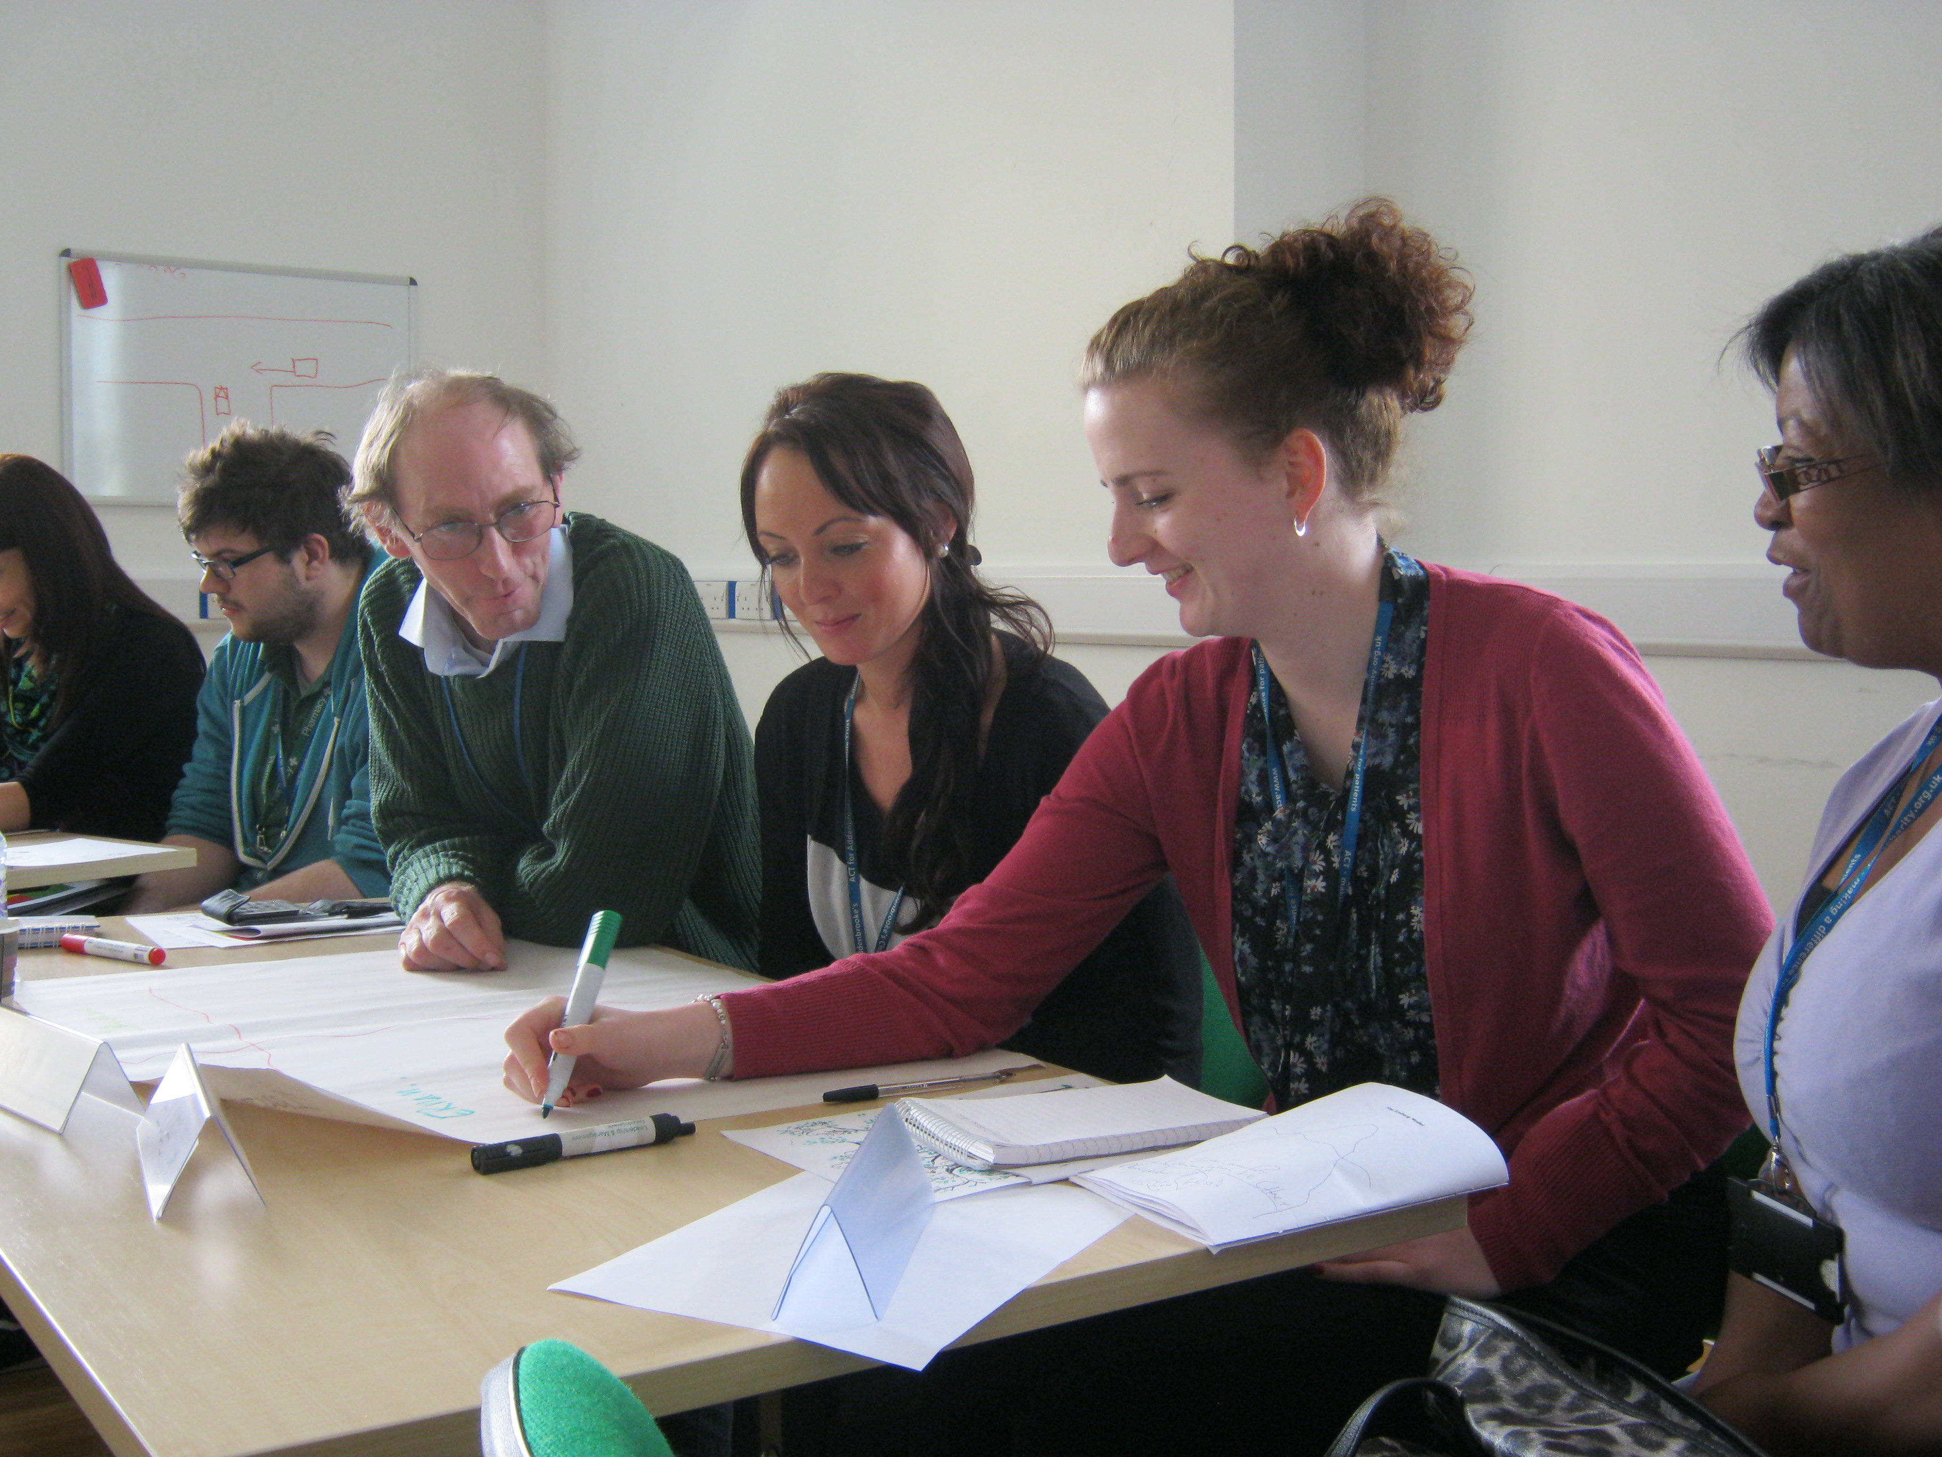
There are also free skills booklets available from the Voluntary Services department on a range of topics of interest and use to volunteers e.g. confidence in interacting with patients.

Supervision and review
You will have a named placement supervisor within your host ward/department to provide day-to-day support and feedback and to be a first point of call for any problems or issues that may arise. You can also contact the Voluntary Services department at any time if you have unresolved concerns about your placement.

A Voluntary Services member of staff or a link volunteer will contact you after 6-10 hours volunteering for an initial review to discuss how their placement is progressing. At the end of 16 weeks, you will receive another review, with opportunity to continue in your current role or in a new placement (depending on availability). This process is on-going, enabling each volunteer to reflect upon their volunteering activity and consider the impact it has for themselves and for patients.

At the end of your volunteering placement you will be asked to complete a leaver’s form and an exit questionnaire, which will include the reason for leaving and any comments and suggestions you have. This will allow us to evaluate the service on a regular basis and where possible, to make improvements.

Communications
There is opportunity at any time for you to talk with a voluntary services member of staff to discuss aspects of volunteering or any queries a volunteer may have. General information updates and items of interest relevant to volunteers are provided on the daily boards in the voluntary services office, via a weekly emailed newsletter ‘the Friday Bulletin’.

Dealing with complaints
The Trust will respond to any complaints made by or concerning volunteers in a full, fair and consistent way. If a complaint is made by a volunteer or concerning a volunteer, these will be resolved informally wherever possible, with the involvement of the Head of Voluntary Services. If informal resolution is not possible, the volunteer problem solving process will be followed. Details of the process that is followed are available on request from the Voluntary Services department.

Care First (Tel: 0800 174319)
This is the Trust’s free advice, information and counselling service for staff and volunteers. It is free of charge, available 24 hours a day, 365 days a year and there is no limit to the number of times you can contact the service.

The service is completely independent from the Trust whilst provided by the Trust, and your call will always be treated in the strictest confidence.

You can call about anything that is troubling you whether it is personal difficulties e.g. family matters, relationships, loss or bereavement, consumer/trading standards issues, housing, benefits etc.

Attendance

Reliability
We ask volunteers to make an initial commitment of 26 weeks (16 weeks for the Young Person’s Programme whose volunteers are in full time education), in the light of the investment we undertake to recruit, train and support our volunteers. However as a volunteer you are under no legal obligation to stay but we would always appreciate some notice if you decide to leave us.

Volunteers accept a placement that is carried out on a specific day and time. We ask that you keep to the volunteering arrangements made with your host ward/department so that consistency of volunteering support is maintained within that area.

Illness and holidays
Your placement may involve contact with people who are vulnerable to illness, such as the elderly and it is therefore important to minimise the risk of infection. For this reason, if you are ill please do not come to your volunteering session. If you are unable to attend due to illness or unforeseen circumstances then please let your placement area and the Voluntary Services department know at the earliest opportunity.

You must inform the Head of Voluntary Services if you have been in contact with someone suffering from an infectious disease, e.g. typhoid, measles, hepatitis, salmonella and viral diarrhoea and vomiting

If you have a holiday planned, please let the Voluntary Services department know as soon as possible that you will be unavailable for certain dates and when you plan to return.

Changes to volunteer placements
Please notify the Voluntary Services department if you need to change the day or time that you volunteer.

If you wish to change your volunteer role for any reason, please contact the Voluntary Services department. We try to accommodate changes in placements but this will be on the basis of availability of an alternative and your suitability for the role.

Volunteer breaks in service
If you wish to take an extended break from your regular volunteering duties, with a view to returning after a period of time please be aware that you will need to undergo pre-placement checks if the break in service exceeds 6 months.

Suitability of the volunteer role
If you or your host ward/department consider that your volunteering role does not suit you and/or you have not been able to provide reliable attendance, a discussion will take place to ascertain if you should wish to leave or consider an alternative volunteer placement with us that may suit you better.

Ending your volunteering with the Trust
Volunteering is a mutual arrangement between the volunteer and the Trust, which can be terminated at any time. Where possible, we ask that you give as much notification as possible in order that we can make suitable arrangements to ensure there is no impact on continuity of service.

When you leave, you should return your uniform, ID badge and lanyard to the Voluntary Services department. We will be pleased to provide you with a Certificate of Appreciation and also a reference if requested.

The NHS Retirement Fellowship is open to ex-volunteers who would like to participate in a range of social events with other ex NHS volunteers and staff. The Voluntary Services department can provide you with details.

Expenses and Discounts

Travel expenses
If you use your own car to travel to and from the hospital, a mileage rate is payable up to a 30 mile journey limit. Volunteers are eligible for free car parking on the hospital site at car park H at the front of the hospital. Your ID badge is required to swipe you through the security gate of the car park.

Where volunteers use public transport to travel to and from the hospital, the cost will be reimbursed on production of public transport tickets. You have a responsibility to choose the most cost-effective public transport route.

Travel costs are claimed on a monthly basis using a volunteer expenses form obtained from the voluntary services office, and are paid directly into your bank account once approved. You will need to complete a Personal Details for Payment Purposes form (see form at the back of this handbook) and submit to the voluntary services office a.s.a.p. so that your subsequent claim forms can be processed.
NHS Discounts
Volunteers are entitled to a range of NHS benefits and discounts, which include discounted local shopping and facilities in the Cambridge area. Details of NHS discounts and benefits can be obtained from the Voluntary Services office.

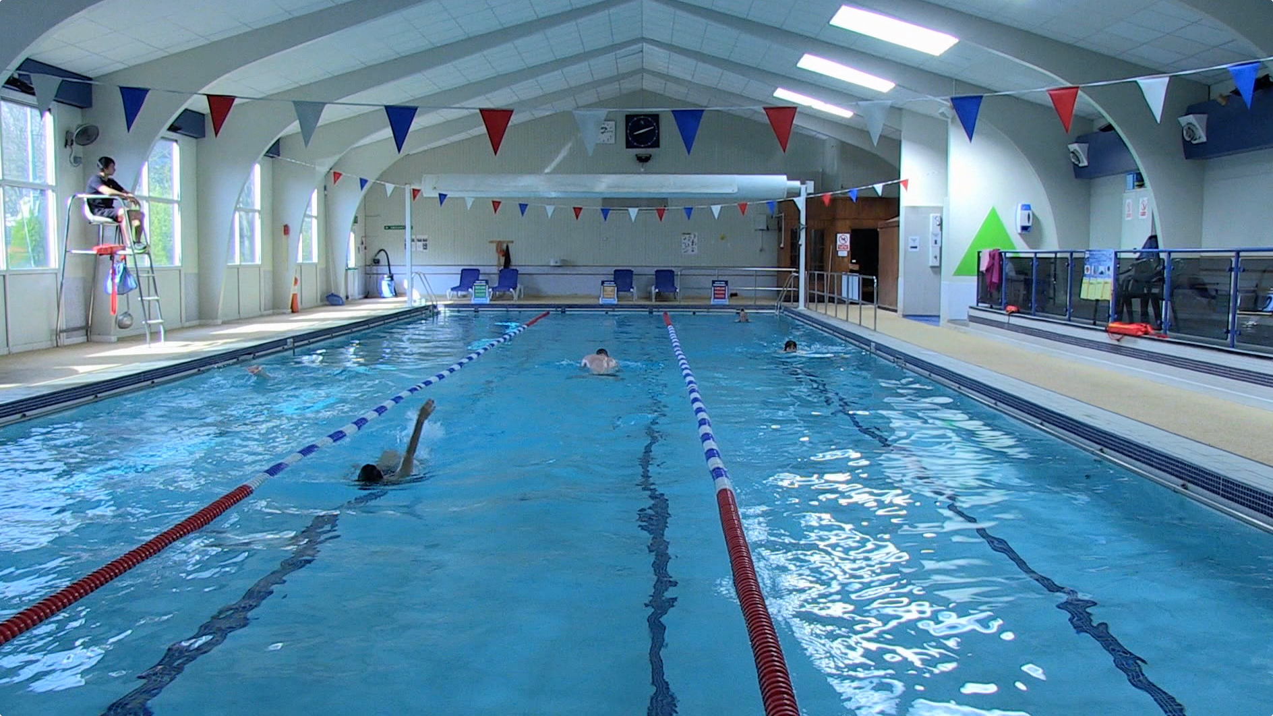

This includes the opportunity to join The Frank Lee Leisure and Fitness Centre on the hospital site, which offers quality and affordable onsite fitness facilities, with a number of membership options available.

THANK YOU!

Your contribution

The time, energy and commitment you give our hospitals, patients and staff mean a lot to us.

Each year during the summer we celebrate the amazing work of our volunteers by holding an annual celebratory lunch at which the Chief Executive and Chairman of the Trust attend. As a volunteer we will be delighted to invite you, and you will receive details of the event nearer the time!

As a volunteer you are automatically enrolled as a CUH Foundation Trust member. This is free and means that you can have your say about the issues that really matter to you by contacting one of the staff governors. There is also a member’s newsletter which provides updates on what’s happening in our hospitals as well as volunteering news. Please contact the Voluntary Services department to find out more.

If you have any questions or concerns in relation to this handbook or your volunteer placement, please do not hesitate to contact the Voluntary Services office:

Contact us:

01223 586616 (Mon – Fri 8am until 7pm)
Email: volunteer@addenbrookes.nhs.uk
Bleep: 157 667
Voluntary Services Department
Cambridge University Hospitals
Box 214, Hills Road, Cambridge, CB2 0QQ

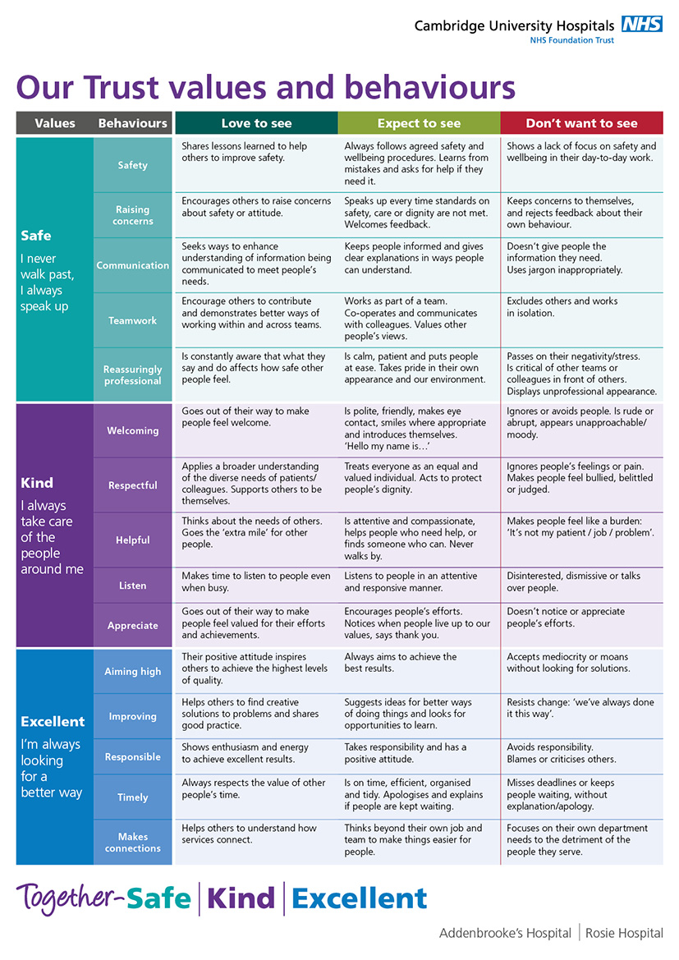

Voluntary Services Department
Personal Details for Expenses Payment Purposes

Surname
Forename(s)
Title |  |  |  | Gender | Female |  |  |  |  | Male
Date of Birth |  |  |  | National Insurance No.
Address
 | POST CODE:

Bank Account Details

Sort Code
Account No.
Account Name
Name and Address of Bank
POST CODE:

Is this a one off claim?  (COMPULSORY) | YES | NO

VOLUNTEER SIGNATURE………………………………………………Authorised Signatory…………………… VOLUNTEER NAME……………………………………………………………………. DATE......................
REF:
FIN CODE:
START DATE: |  | END DATE

FOR OFFICE USE

ESR Number:

Innovation and excellence in health and care Addenbrooke’s Hospital | Rosie Hospital

Voluntary Services – Volunteer Travel & Expenses Claim Form

Full Name |  |  |  |  |  |  |  |  |  |  | Base Name |  |  |  |  |  |  | Box 214 Addenbrooke’s
ESR No |  |  |  |  |  |  |  |  |  |  | Home to base mileage |  |  |  |  |  |  | (one way)
Home Address
Date of travel | Journeys: Enter “Home”, “Base” , or Postcode |  |  |  | Mileage |  |  |  |  |  |  |  |  |  |  |  | Fares/Parking (Receipts must be attached)
 | Start: |  |  | End: | Car |  | Motor Cycle | Bicycle | Passenger name & Miles |  |  |  |  |  |  |  | Specify type e.g. Train, Bus, parking etc. |  |  | Amount £
 |  |  |  |  |  |  |  |  |  |  |  |  |  |  |  |  |  |  |  |  |  |  |  |  |  | Volunteering |  |  |  | Volunteering
Submission of Claims
Claims should be no more frequently than monthly and no less frequently than quarterly. Staff claiming more than 100 miles must submit a monthly form. The Trust may refuse claims submitted excessively in arrears.
Date(s) claimed for |  |  | Type of expense |  |  |  |  |  |  |  |  | Receipt attached (tick) |  |  |  |  |  |  |  |  |  | Cost (£)
Total subsistence / other expenses cost to be paid |  |  |  |  |  |  |  |  |  |  |  |  |  |  |  |  |  |  |  |  |  | £
You must complete all the relevant totals in order for them to be authorised by your manager in accordance with regulations |  |  |  |  |  |  |  |  |  | Motorcycle miles |  |  | Bicycle miles |  |  | Car mileage |  |  | Passenger miles |  |  | Fares/parking fees
Total to be paid - Mileage/amount claimed per category |  |  |  |  |  |  |  |  |  |  |  |  |  |  |  |  |  |  |  |  |  | £
Volunteer Declaration
I declare that:
- No other claim has been made by me to any other organisation in respect of the duties performed during the period stated above
- I am aware that I should check with my insurance company that I am covered for commuting to and from my voluntary work. I am aware that falsification of a travel / expense form is a serious offence and can lead to summary dismissal.

Print Name |  |  |  |  |  | Signature |  |  |  |  |  |  |  | Designation  Volunteer |  |  |  |  |  |  | Date
Managers Authorisation – Prior to authorisation, please ensure the above totals are completed confirming the miles/amount being claimed in line with audit regulations. I certify that to the best of my knowledge and belief, the claimant was engaged on the duty stated on the dates shown overleaf and above and that the claims for expenses are in accordance with the Trust's Financial instructions and Trust's Travel and Associated Expenses Policy

Print Name Linda Hering/Anna Ellis |  |  |  |  |  | Signature |  |  |  |  |  |  |  | Designation  Head of Dept./V.S.Manager |  |  |  |  |  |  | Date
Cost Centre 3538 – R3640 Version NOV 2015 – Voluntary Services

APPENDIX 1

WELCOME – to All Volunteers from the
Moving and Handling Team

Key information the moving and handling team want you to be aware of:-

- What is moving and handling?
- What is good body posture?
- What your responsibilities are regarding moving and handling and your safety?
- Where to get additional moving and handling advice?
- Who to report areas of concern to e.g. slippery floors or broken equipment?

What is moving and handling?

The Health and Safety Executive state that moving and handling is:-

Any transporting or supporting of a load. This includes lifting, putting down, pushing, pulling, carrying or moving) by hand or bodily force. The force applied is human, not mechanical. Health and Safety Executive (HSE) 1992

What is a load?

Anything which is moveable. A person could be a load, or an inanimate object e.g. box, trolley or bed could be a load.

What is good body posture?

- Good body posture is making sure that you maintain a stable base.
- When moving a load, bring the load close to you and ensure a good grip, bend knees and move your feet.

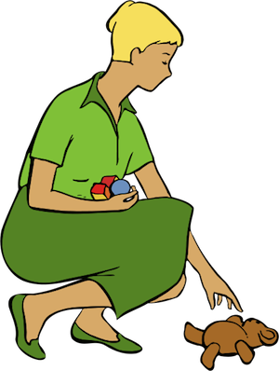

What your responsibilities are regarding moving and handling and your safety?

Healthcare settings can pose significant moving and handling challenges and risks. This Trust wants to keep you safe so advises that all volunteers should not undertake any moving and handling activities. Please ask the Trust staff to undertake these for you.

On no account should volunteers lift or move equipment or furniture. Volunteers must also never attempt to lift patients; this includes helping them in and out of cars, in and out of chairs, in and out of bed; transferring from or into wheelchairs. Volunteers must not support patients who need physical assistance to walk.

The main exception to this is the wheelchair volunteers who after practical training with the moving and handling or learning and development team can transport patients using this training.

The Trust’s Combined Liability Insurance covers suitably trained volunteers, of any age, engaged in escorting patients or pushing patients in wheelchairs, provided that:

- The volunteer is registered with Addenbrookes Voluntary Services Department.
- The volunteer is in good health and has informed Voluntary Services Department if receiving any medication.
- The volunteer is acting in accordance with a request from the manager or supervisor of the placement area.
- The volunteer has attended a training course in moving & handling techniques appropriate to the needs of the placement.
All volunteers have responsibilities imposed upon them under the Health and Safety at Work Act 1974 and the Management of Health and Safety at work Regulations 1999.

- To take reasonable care for the health and safety of him or herself and of any other person that may be affected by his activities.
- Must co-operate with the employer in respect of health and safety matters.

Where to get additional moving and handling advice?

If you want more moving and handling help please ring Ext 6660

Who to report areas of concern to e.g. slippery floors or broken equipment?

Please inform the person in charge of the area immediately of areas of concern e.g. broken equipment slippery floors, and if appropriate the Head of Volunteering.

END Appendix 1

APPENDIX 2

HOW TO: Safely handle a manual wheelchair

Knowing how to handle a wheelchair safely is important for reducing the risks of injury to both the wheelchair user and the person pushing the wheelchair.

- DO check the wheelchair is in good working order and report any problems or defect immediately (e.g. flat tyres, brakes not working)
- DO ensure you are dressed appropriately for pushing a wheelchair - flat secure shoes offer greater stability
- DO ensure the users clothing, scarves, sling straps, oxygen tubing, feed tubes etc. cannot become entangled on the wheels or hooked over armrests and footrests
- DO ensure you know how to operate the brakes and that they are always on when the wheelchair is not in motion
- DO adjust the height of push handles where possible to prevent you stooping
- DO ensure you maintain a good posture – keep upright, push using the power of your legs, keep close to the chair and don’t twist
- DO ensure you talk directly to the wheelchair user

- DON’T overload the back of the wheelchair with heavy bags as it alters the stability of the chair
- DON’T add cushions or other accessories without assessment from a therapist
- DON’T stoop when making checks and adjustments to footrests
- DON’T lean on the wheelchair
- DON’T take over the person’s wheelchair and push them, if they don’t require assistance.

GOING DOWN A STEP/KERB

- Communicate with the wheelchair users throughout the manoeuvre
- If present and consent is given ensure the lap strap is fastened
- Reverse the wheelchair to the edge of the step/kerb
- Pull the wheelchair to towards you allowing the rear wheels to roll gently over the kerb and down, using your body weight as a counterbalance
- Lower the front wheels onto the receiving surface.

DOORS

- Get assistance from another person, where possible, to hold the door open
- Avoid banging the footrests into the door to open it
- Doors that push open: brace with your body and reverse wheelchair user through doorway
- Doors that pull open: open door and brace with your arm as you push the wheelchair through
- Ask the wheelchair user to tuck in their elbows to avoid injury.

HOW TO PUSH A WHEELCHAIR FROM A USER’S PERSPECTIVE

- *ASK ME BEFORE YOU START TO PUSH*
- Understand that the wheelchair is an extension to my body
- I am still in control even though you are pushing
- Aim for a smooth rise, no sudden stops, starts or turns
- Do not lean on the chair
- Look where you are going – avoid glass, chewing gum, dogs mess
- Keep an eye out for raised paving slabs
- Beware of other pavement users
- No texting or answering your phone when you are pushing me
- Steer away from cobblestones, uneven floors as the vibration can be painful
- Bumps are painful – warn me, try to avoid them, steer around or go slowly
- Avoid recently laid tarmac
- Avoid puddles
- Never ever let go without telling me
- Don’t speak for me
- When talking to me come down to my level to avoid me twisting and looking up all of the time
- When we stop consider where you are going to leave me and what I am looking at (e.g. don’t leave me looking at a wall – it does happen)
- Put the brakes on when stopping

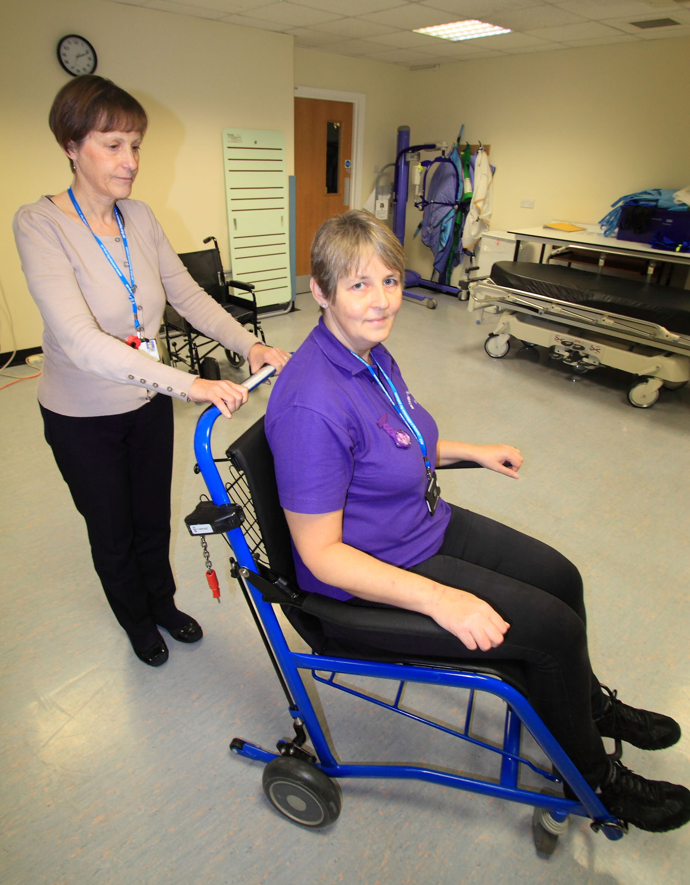

END Appendix 2

